Connect to Cerberus and select the system you want to deploy

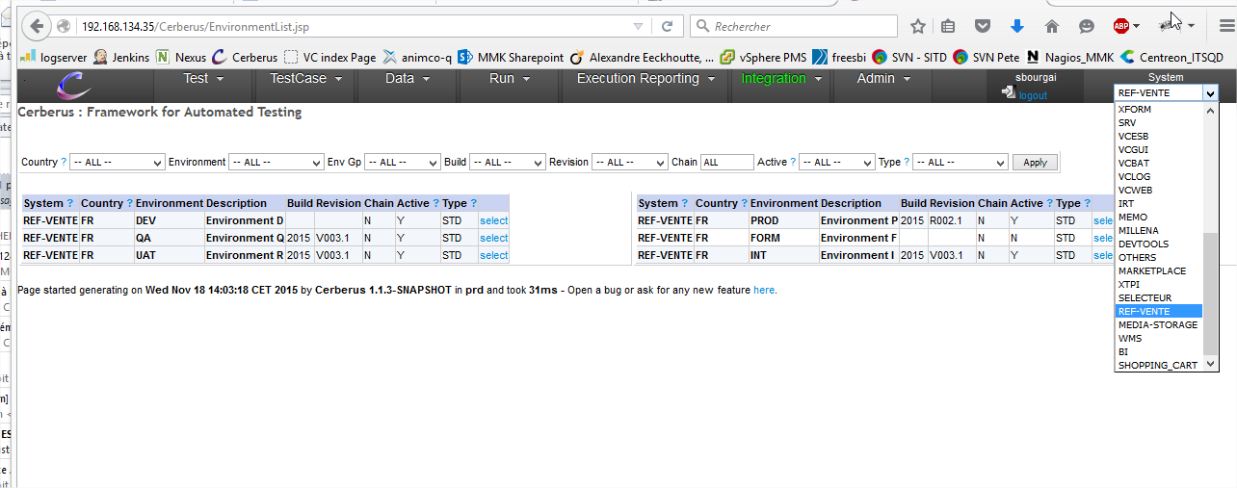

Then, go to menu ‘integration > environments’

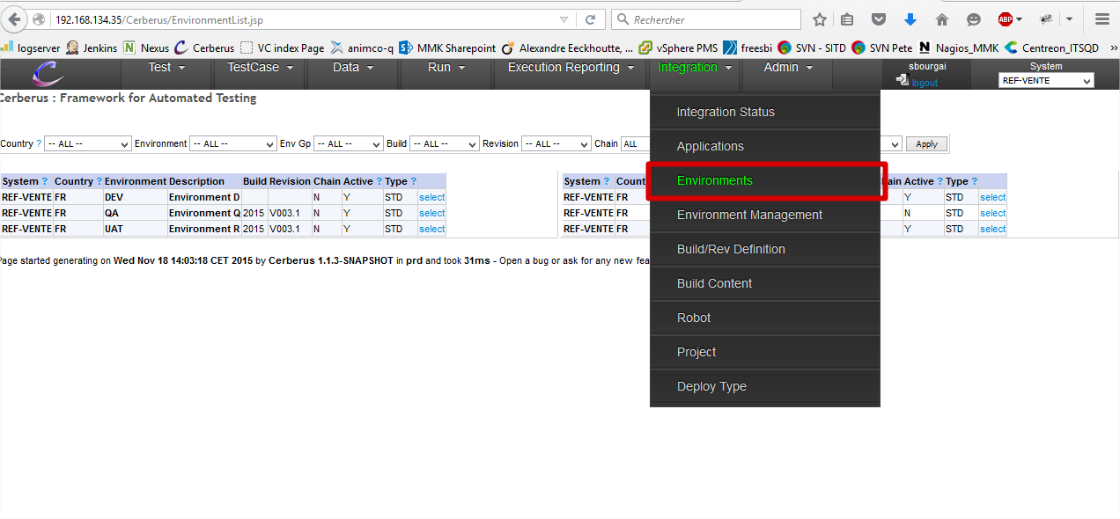

You select the environment you’ve been requested in the MOSS ticket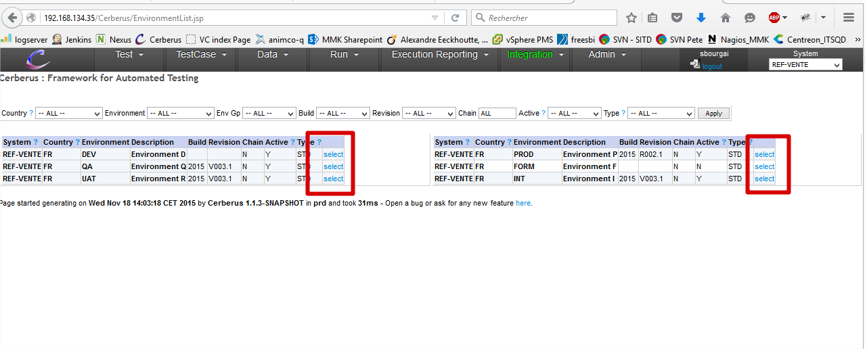

1. Check every informations :
   * System
   * Country
   * Environment
   * Is the env currently active ?

Note : the environment will be “not active” during the deploy, so no test will run during a deploy.

When you’re ready to start:

1. Click the ‘disable environment’ button

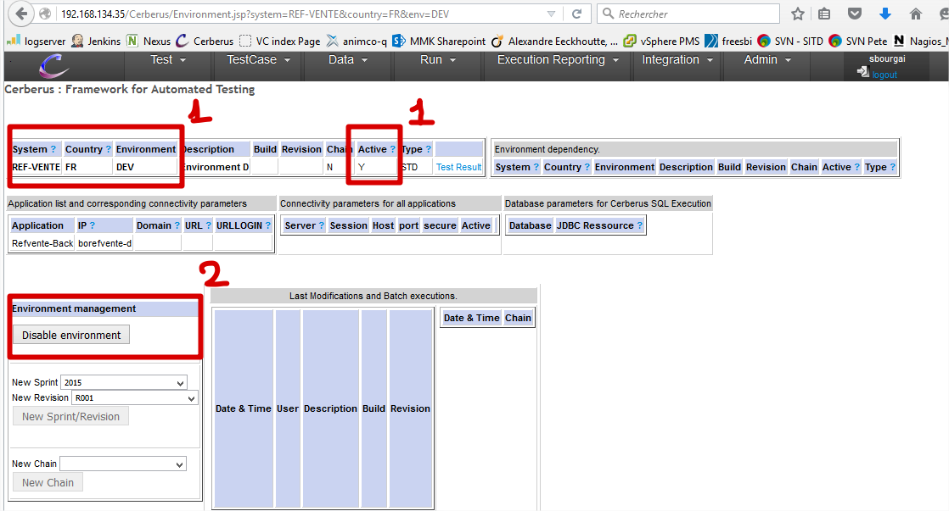

In the following page you see the mail sent to the people working on the application to warn’em the environment is being upgraded

Check :

1. Env, application, system, current version (you have deployed nothing yet)
2. And click the ‘validate and send notification’ button 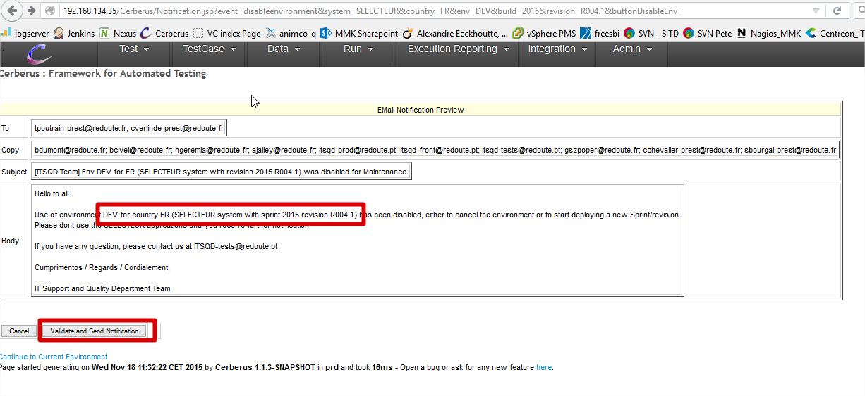

Check again :

1. Env, application, system, current version (you have deployed nothing yet)
2. Check the list of upgrades embedded in the new version (this list cannot be empty)

And you can start the deploy

1. If you have an automated deploy application you’ll have a link to trigger the deploy

Otherwise, a link to the delivery is shown. Then, refer to the deploy procedure you have about it

1. In case of an automated deploy, check the Jenkins deploy log

Finalise the deploy

1. Once every deploy is done, click on the ‘validate and send notification’ button to warn everyone the deploy is done

